**Scraping And Summarizing The Last Arabic News**



**Faculty of Information Technology College**

**Department of Computer science**

**By**

Zeid Zein Alabdeen

20160426

**Supervised by**

**Dr. Issam Dawood**

June 2019COMMITTEE REPORT

We certify that we have read this graduation project report as examining committee, examined the student in its content and that in our opinion it is adequate as a project document for B.Sc. in Computer sciensce .

Chairman: Supervisor:

Name: . . . . . . . Name: . . . . . . . .

Signature . . . . . . Signature . . . . . .

Date: / / Date: / /

Examiner:

Name: . . . . . . .

Signature . . . . . .

Date: / /

تقرير الجنة المناقشة

نؤيد بأننا قرأنا هذا التقرير كلجنة مناقشة وإمتحنا الطلبة بمحتوياته ونشهد بأنها كافية كتقرير لمشروع تخرج لنيل درجة البكلوريوس في تخصص علوم الحاسوب .

|  |  |
| --- | --- |
| عضو اللجنة : | رئيس اللجنة : |
| الاســم : ............................................... | الاســم : ............................................... |
| التوقيع: ................................................ | التوقيع: ................................................ |
| التاريخ: ......../........../............................ | التاريخ: ......../........../............................ |
|  |  |
|  | المشرف : |
|  | الاســم : ............................................... |
|  | التوقيع: ................................................ |
|  | التاريخ: ......../........../............................ |

# Abstract

This project was developed to take advantage of the huge amount of Arab news on the Internet and to summarize and collect it in one place where the user can browse the news from different sources in one place and read a simple summary of each news before reading the full article .

# Dedication

It is our genuine gratefulness and warmest regard that we dedicate this work to our lovely Mothers: "Wafa'a Al-rawashdeh ","Fozeya Nafee", "Wojdan Ayyash", "Faten alkhateeb", and thanks for nursing us with affections and love and your dedicated partnership for success in our life.

This is for our Fathers "Mahmoud Nassar", "Yousef Farhan", " Hossam Hussien", and “saeed ALkhateeb”. Thanks for always kept us working when we wanted to give up, for your trust of our dreams and thanks for all Delicious meals.

This is for our Fathers "Mahmoud Nassar", "Yousef Farhan", " Hossam Hussien", and “saeed ALkhateeb”. Thanks for always kept us working when we wanted to give up, for your trust of our dreams and thanks for all Delicious meals.

All our love to brothers and sisters, for finding us the light, whenever it far away.

My thank go to Dr. Ahmed Alamm for standing by me and providing me with all kinds of support to get to this stage .

My thanks go to my supervisor and teacher, Dr. Essam Al-Daoud, who always guides me and provides Support me during my university career.

We are grateful to many persons who shared their memories and experiences, especially friends, colleagues, students, teachers, archivists, and other librarians who assisted, advised, and supported our project and writing efforts over the years whose friendship, hospitality, knowledge, and wisdom have supported, enlightened, and entertained us over the many years of our friendship. They have consistently helped us keep perspective on what is important in life and shown us how to deal with reality.

**Zeid Zein Alabdeen**

# Acknowledgment

This work done thank to Allah, I dedicate for my familie, And my friends and the all thanks to Dr. Issam Dawood, who helped me . He gave me enough information to complete and the success of the project and end it on this way you deserved from me special thanks and thank the teaching staff in the faculty’s Dear faculty of science and technology information and all thanks to everyone who has helped us in this project.

**Zeid Zein Alabdeen**

Table of Content

Abstract I

Dedication II

Acknowledgment III

1 Table of figure: VII

1. Chapter One Introduction 1

1.1 Background 2

1.2 Introduction 2

1.3 Problem 2

1.4 Proposed Solution 2

1.5 Project Goals 3

1.6 Software Process method: 3

1.6.1 Agile Model vs. Waterfall Model: 3

1.6.2 How we implement Scrum model: 7

1.7 Technology 7

1.7.1 Languages 7

1.7.2 Editors and Other Tools 9

1.8 Skill and knowledge 9

1.8.1 Professional Skills 9

1.8.2 Technical Skills 10

1.8.3 Personal Skills 10

1.9 Initial Requirements: 11

1.9.1 Initial Functional Requirement 11

1.9.2 Initial Non-Functional Requirements 11

1.10 Scope 12

1.10.1 In scope 12

1.10.2 Out of scope 12

1.10.3 Assumptions 12

2. Chapter two: Project Planning &Decisions 13

2.1 Introduction 14

2.2 Communication Plan 14

2.2.1 Definition 14

2.2.2 Work mechanism 14

2.3 Risk Management 15

2.3.1 Risk Management 15

2.4 Testing plan 17

2.5 Issue log problem in plan 17

2.6 Progress planning 17

2.7 Marketing research 17

2.8 Business plan 18

3. Chapter Three: Development Activities& Outcomes 19

3.1 Introduction 20

3.2 System Requirements 20

3.3 User stories analysis 20

3.4 Non Functional Requirement 22

3.5 Design and analysis system 23

3.5.1 Use case model 23

3.5.2 Activity diagrams **Error! Bookmark not defined.**

4. Chapter Four: Quality for Test Activities& Outcomes 25

4.1 Introduction 26

4.2 Tested each sprint separately 26

4.3 Tested the integration of the sprints 26

4.4 Checking to it usability: 26

4.5 Checking to it acceptance: 29

4.6 Checking and ensure the document: 29

5. Chapter Five: Implementation Activities &Outcomes 31

5.1 Introduction 32

5.2 Installation requirements 32

5.3 Development Constraint 33

5.3.1 How to install Tools 33

6. Conclusion&Future work 34

6.1 Introduction 35

6.2 Conclusion 35

6.3 Future work 35

# Table of figure:

Figure (‎1‑1): Scrum Model 4

Figure (1‑2): Waterfall Model 5

Figure 3 Use Case Diagram 23

Figure 4 Activity diagram for search item 24

Figure (4‑1): Idea research result 27

Figure (4‑2): Missing function research result 27

Figure (‎1‑3): Satisfaction research result 28

Figure (‎1‑4): Interesting to use research result 29

# Chapter One Introduction

## Background

With the present explosion of data circulating the digital space, which is mostly non-structured textual data, there is a need to develop automatic text summarization tools that allow people to get insights from them easily. Currently, we enjoy quick access to enormous amounts of information.

## Introduction

This proposal document outlines the first part briefly describes the area of inquiry It expands on to the description of the proposed solution, including its benefits and environment in terms of the client’s requirements. The later part describes Technical part.

## Problem

Because of the large amount of news on the Internet, it is difficult for users to browse all these news except by visiting a number of news sites. Often the articles are medium in size, as the reading process takes a lot of time, which wastes time, and it is difficult to know the most important news for the reader except after reading the whole article.

## Proposed Solution

As the developmer , to solve this problem me create an web application that called "Arab News", It works on collecting Arab and international news from several Arab and international websites, them classifying them into several sections , them summarizing and presenting them in my application that allows access to this offer fast and easy it News and precise summarize of texts while focusing on the sections that convey useful information .

## Project Goals

* quick access to enormous amounts of information.
* Facilitate the process of collect from all web site.
* Categorize the News into group.
* summarizers NEWS to get useful information and leaves out inessential
* Help users know the most read news

## Software Process method:

To develop this software, we used the agile software development methodology by using Scrum as our key development process. Scrum is a subset of Agile and one of the most popular process frameworks for implementing Agile. It is an iterative software development model used to manage complex software and product development. Fixed-length iterations, called sprints lasting one to two weeks long, allow the team to ship software on a regular cadence. At the end of each sprint, stakeholders and team members meet to plan next steps.  We have selected this approach for three main reasons, Firstly the work requires constant invention, so all steps are not known in advance, and estimates are not expected to be reliable, secondly the requirements change frequently, even from month to month, finally success is defined by responsiveness to customer requests so, Requires quick turnaround (2—4-week Sprints) for high-priority requests.

### Agile Model vs. Waterfall Model:

We believe that technology, businesses and markets change so fast these days that software development needs to be adaptable above all other qualities.

Agile methods are more flexible than the waterfall method which means that customers’ requests are more likely to be met. Even when things change the constant focus on value means what you’ve already delivered should have been worthwhile. And the rhythm that Scrum creates helps build highly motivated teams where productivity increases over time.

Scrum Model:

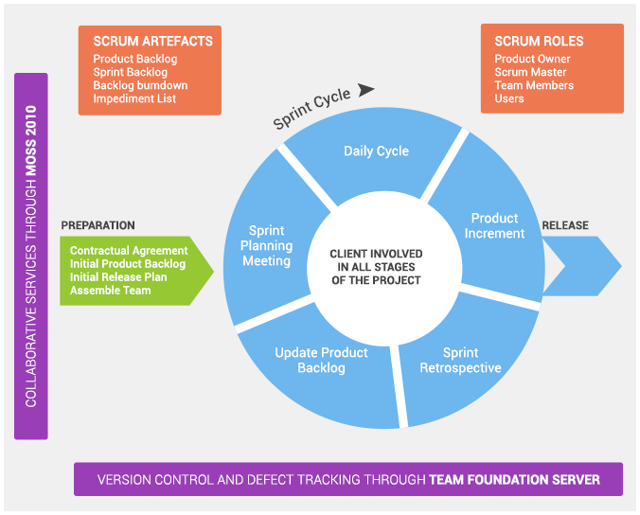

Figure (‎1‑1): Scrum Model

Waterfall Model:

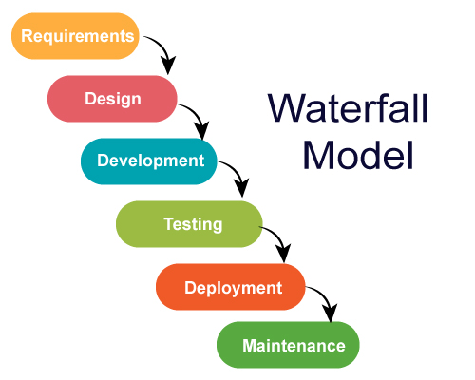

Figure (1‑2): Waterfall Model

**Some disadvantage and advantage for both:**

**Advantages of the Waterfall Model:**

* Simplistic to implement and execute for projects and/or companywide.
* Limited demand on resources.
* Large emphasis on documentation.

**Disadvantages of the Waterfall Model:**

* Completed phases can be revisited regardless if issues arise within a project but with high cost.
* Accurate requirement is never gathering prior to the completion of the requirement phases.
* Phase due to the lack of clarification in regard to client’s desires.
* Small changes or errors that arise in applications may cause additional problems.

**Advantages of the Scrum Model:**

* More transparency and project visibility: With daily stand-up meetings, the whole team knows who is doing what, eliminating many misunderstandings and confusion. Issues are identified in advance, allowing the team to resolve them before they get out of hand.
* Increased team accountability: There is no project manager telling the Scrum Team what to do and when. Instead, the team collectively decides what work they can complete in each sprint. They all work together and help each other, improving collaboration and empowering each team member table independent.
* Easy to accommodate changes: With short sprints and constant feedback, it’s easier to cope with and accommodate changes. For example, if the team discovers a new user story during one sprint, they can easily add that feature to the next sprint during the backlog refinement meeting.
* Increased cost savings: Constant communication ensures the team is aware of all issues and changes as soon as they arise, helping to lower expenses and increase quality. By coding and testing features in smaller chunks, there is continuous feedback and mistakes can be corrected early on, before they get too expensive to fix.

**Disadvantages of Scrum model:**

* Selling software with Agile Methodologies is quite challenging since the question “how much will this cost me” arises and an ambiguous answer is not what clients want to hear.
* The learning curve is repeated with every client.
* Heavy client participation is required and although clients are told this in the sales cycle, the first couple weeks of the project sometimes overwhelm the client.
* Developers do have client-facing roles and training them on this matter is required.
* Poor client participation directly affects product quality.

### How we implement Scrum model:

I start me project by determine the Scrum role, sprint master and then listed the project backlog

After that I define the deadline for each sprint, and have gone to work on the top few priority items in the backlog.

For each sprint have done the functionality test, and have tested the integration test finally.

## Technology

Description of the chosen technologies we will use in the project, from the choice of language and tools.

### Languages

* Python

Python is an interpreted, high-level, general-purpose programming language. Created by Guido van Rossum and first released in 1991, Python's design philosophy emphasizes code readability with its notable use of significant whitespace. Its language constructs and object-oriented approach aim to help programmers write clear, logical code for small and large-scale projects.

Python is dynamically typed and garbage-collected. It supports multiple programming paradigms, including procedural, object-oriented, and functional programming. Python is often described as a "batteries included" language due to its comprehensive standard library.

### Editors and Other Tools

* **Anaconda platform**

Anaconda is a free and open-source distribution of the Python and R programming languages for scientific computing (data science, machine learning applications, large-scale data processing, predictive analytics, etc.), that aims to simplify package management and deployment. Package versions are managed by the package management system conda. The Anaconda distribution includes data-science packages suitable for Windows, Linux, and MacOS.

* **Google Forms**

Google forms are a tool that is part of Google Drive for creating surveys, tests, or web input forms. Google forms allow anyone to create an easy to use web form, tie it to a spreadsheet where you can track results and post it on the web without having to know programming.

It helps us to create a web input form to find out how the shops and furniture showrooms accept our program idea and after we finish our tool it help us to create a web forms to testing the usability and accessibility for our tool.

## Skill and knowledge

Description of the skills that are available , identification of skills that will need to improve on and individual roles and responsibilitie of individual member and their learning.

### Professional Skills

* Time management
* Communication
* Planning
* Risk assessment
* Testing
* Teamwork
* Problem solving
* Documenting
* Presenting
* Researching

### Technical Skills

• Algorithm analysis and design.

* Use case design.
* Activity diagram.
* User interface design.
  + Usability testing.
  + Acceptance testing.

### Personal Skills

**Zeid Zein Alabdeen**

Communication

Python development

Data science

Machine Learning

Deep Learning

Oracle SQL/PLSQL

Web development

## Initial Requirements:

### Initial Functional Requirement

1) The user should be able to view all NEWS

2) The user should be able to view specific News category

3) The user should be able to search article specific

4) The user should be able to mark NEWS to his favorite list

### Initial Non-Functional Requirements

1. Usability
2. Acceptance tool

## Scope

From the Entrepreneurs meeting, I have a basic idea of what the tool needs and how the tool will develop. Therefore, this scope aims to address what is realistically achievable (in scope) and the aspects of the system that will not be considered for development (out of scope). The Arab NEWS tool will have the following specifications.

### In scope

• Search the News that user entered .

• Showing News for specific Websites

• Showing News in Specific area

• Provide different collections of News from all Websites.

• Provide different collections of summraize from all News.

### Out of scope

• This tool cannot obtain news from websites that fight scraping

• This tool cannot summarize short texts

• This tool does not provide intellectual property rights and all rights belong to the source

### Assumptions

• The project completed in 8 weeks.

• The chosen online resources are accurate and reliable.

• All functionalities work effectively and efficiently.

# Chapter two: Project Planning & Decisions



## Introduction

Planning is one of the most important project management and time management techniques. Planning is preparing a sequence of action steps to achieve some specific goal. If you do it effectively, you can reduce time and effort to achieve the goal.

A plan is like a map. When following a plan, you can always see how much you have progressed towards your project goal and how far you are from your destination. Knowing where you are is essential for making good decisions on where to go or what to do next.

One more reason why you need planning is again the 80/20 Rule. It is well established that for unstructured activities 80 percent of the effort give less than 20 percent of the valuable outcome. You either spend much time on deciding what to do next, or you are taking many unnecessary, unfocused, and inefficient steps.

## Communication Plan

### Definition

A communication plan documents the proposed and agreed upon paths and mechanisms of communication across a project. It does involve:

1- Determining the objectives

2- Choosing the audience

3- Selecting appropriate channel to reach them.

In communication plan i have cover everything that result from this project Including setting object and select appropriate channel.

### Work mechanism

At this stage, the project manager studied and analyzed of initial system requirements and based upon identified the adjusted some time to complete some tasks, for example, the process request. Through the expertise of the analyst and project manager initially been given this period of more than a month to complete work tasks.

In our plan we decided that:

* We had met every day 1hour at least to know that:
* What have we done since the last Scrum meeting (yesterday)?
* What will we do before the next Scrum meeting (tomorrow)?
* What prevent us from performing our work as well as possible?
* Every Monday and Wednesday we meeting to work on the project and work as possible as we can.
* We have a group on Messenger to communicate with each other and answer our questions about the tasks that we are doing it.
* We will meet the Dr. one day every weak.

## Risk Management

A risk management plan identifies all possible problems which could lead to delays and/or failures of the project plan. These must be identified very early in the project so that they can be reacted to quickly and will hopefully not hinder the project in any way.

### Risk Management

**Project Risk**

Risk: Tasks not being completed on time/ Failure to meet a deadline.

Probability: High

Estimated Impact: High

Response: Re-schedule and re-prioritize. Understand why there a delay has been and ensure it does not happen again.

Risk: Misunderstanding, either within project team or with client.

Probability: Moderate

Estimated Impact: High

Response: No matter which methodology is used the client should be regularly updated and shown what is going on. These should provide him with a perfect opportunity to clarify what needs to be changed to get back on track

Risk: Group member absent from a meeting.

Probability: High

Estimated Impact: Moderate/ Low

Response: Ensure the member absent is filled in on what happened, ensure they have a valid reason for absence.

Risk: Change in group member roles.

Probability: Moderate

Estimated Impact: Moderate/ Low

Response: Ensure that the reason for the role change is understood; ensure that the entire team is aware of the role change. Try to reduce impact by picking up the new role quickly and asking for assistance where required.

**Technical Risk**

Risk: failure in the code

Probability: high

Estimated Impact: high

Response: rewrite the code and make sure to write comments in the code, it’s easy to edit on the code

Risk: Files lost or deleted.

Probability: Moderate

Estimated Impact: high

Response: The advantage with using Dropbox is that files can be retrieved easily, however if a file is lost from somebodies’ computer or a hard copy of a file is lost the only way to get it back is to re-create it.

Risk: failure in sharing the project

Probability: high

Estimated Impact: high

## Testing plan

Test plans are a way to ensure that all aspects of a product are tested during each sprint of the process, and that nothing gets left out as the project progresses. As the Scrum methodology we follow we had to test every sprint separately to check verification and validation. Then we had to do integration test for the sprints which done. After that we tested the whole tool we developed by test usability, acceptance and ease to use. This insures that all aspects are tested every time.

## Issue log problem in plan

Surely; in any project management face a problem. We face that:

1-Process of online communication outages for one of the members.

2- Absent one of the team members.

3-The time of meeting is conflict with other lectures.

4- Can’t connect from one language to another.

5- The short period to finish the project and the pressure of the term lectures with exams.

## Progress planning

The first step we had to take a learning course in Android to know the environmental work and how to deal with it, to learn the right development way of our tool. We started our course in 20/6 to 20/11.

## Marketing research

To make sure that the tool that we developed has real market in shop businesses and Market customers we conducted a questionnaire for this category and we studied the extent of acceptance for the idea and the desire to apply.

The second way to accept the market research is to make interviews with the User.

## Business plan

We had planning for businesses which include investment, marketing, Competitor analysis, SWOT analysis and financial benefits that will be offered if the tool has Chance to be real business, and we believe it will be. (See the Appendix for the full Business plan).

# 

# Chapter Three: Development Activities& Outcomes



## Introduction

Tool development_ first task

After the process of gathering information and requirements for the system we started work on the first phase of the application development, as part of the plan Set and Scheduled at the beginning of the project, it has been giving the developer responsible for this part of the person concerned in the development and design of the application, of things agreed upon in the development, design and user requirements into account the work that he wants the system ,so we chose Scrum methodology, as we define it the previous part of this document.

The first step in this methodology is an initial requirement and design, get our backlog with costumers and system stories.

We start work in this task in 4/29/2019 and Expected completion of this task in 12/1/2019.

We used to development the tool Android and JavaScript and php as a tool and editor.

## System Requirements

## User stories analysis

1- I want as customer to see the Offers in categories.

2- I want as customer to work with simple interface, so that I can deals with it easy and comfort.

3- I want as customer to see all offers in one screen, so that I can choose the Offer that I want.

4- I want as customer to set the Price of items, so that I can see it in main page.

5- I want as customer to choose the brand, so that I can see what is comfortable with me.

6- I want as customer to choose the item i need, so that I see it in my cart.

7- I want as customer to know 10 tops favorite offers, so I can choose between it.

8- I want as customer to rearrange the Offers, so that I can see the best offer in the top of the page, and the newest offer that added.

9- I want as customer to get the item’s details, so that I can decide to purchase.

## Non-Functional Requirement

**Usability:**

It is the degree to which software can be used by specified consumers to achieve quantified objectives with effectiveness, efficiency, and satisfaction in a quantified context of use. Evaluation allows assessing whether the product under evaluation is effective enough (Can the user complete the tasks they are supposed to perform with the tool? Is their performance complete and accurate?)

**Acceptance:**

It is respecting the user needs, requirements and business processes conducted to determine whether a system satisfies the acceptance criteria and to enable the users, customer to determine whether or not to accept the system.

## Design and analysis system

### Use case model

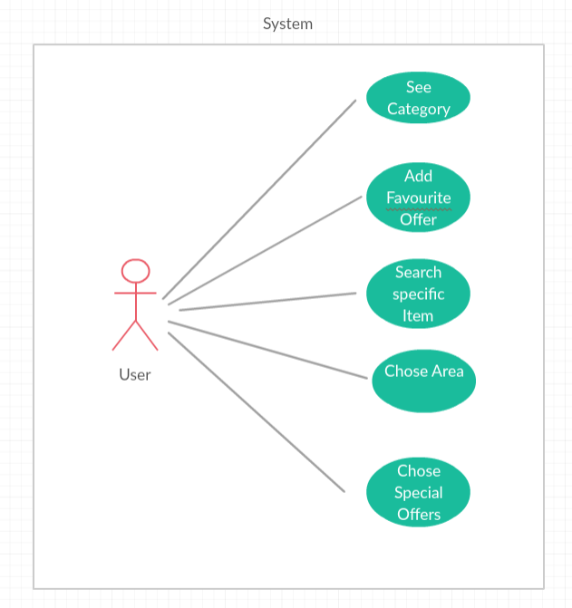

Figure 3 Use Case Diagram

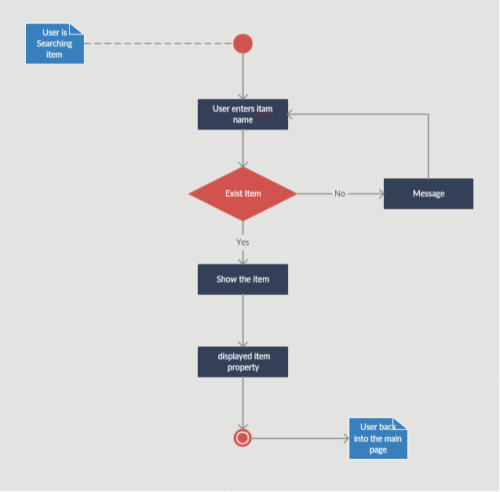

Figure 4 Activity diagram for search item

# 

# Chapter Four: Quality for Test Activities& Outcomes



## Introduction

Test system of the important things that must be done to make sure the basic functions of the tool and that the requirements have correctly translated into the required system.

Like any project or scripts are being tested more than once to ensure quality but should the project analyst manager not to over-process of testing so as to not waste the cost of the project. In order to avoid these mistakes, which falls by the supervisor we have to divide this process into several sections which:

•Be tested each sprint separately

•Be tested the integration of the sprints.

•Checking to it usability.

•Checking to it acceptance.

•Checking and ensure the document.

Explain:

## Tested each sprint separately

When the sprint is completely we have to test the functionality, it is correct or not and to insure if that meet the customer requirements (validation &verification).

## Tested the integration of the sprints

After we completed the all sprints we have to test the compatibility and insure that correct and integrates.

## Checking to it usability:

To make sure of usability we go to the IT department to test the tool.

1- Are you think the idea is usefully?

2-There is any missing functionality? If you answered "Yes" writes it here?

3- How is it easy to use?

4- How are you satisfied with the application?

5- Are you interested in using the application when coming on the market?

We have some Statistics of this question

(Suppose that 1 is the lowest disagree and 5 is the highest agree ).

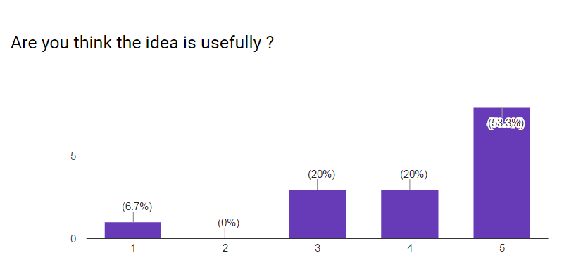

Figure (4‑1): Idea research result

In the figure (4-1) show that 53.3% are believed that the idea is usefully.

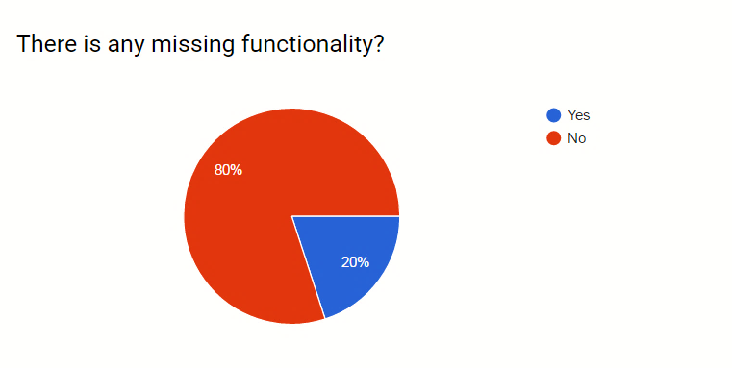

Figure (4‑2): Missing function research result

In the figure (4-2) show that 80% see that no missing functionality.

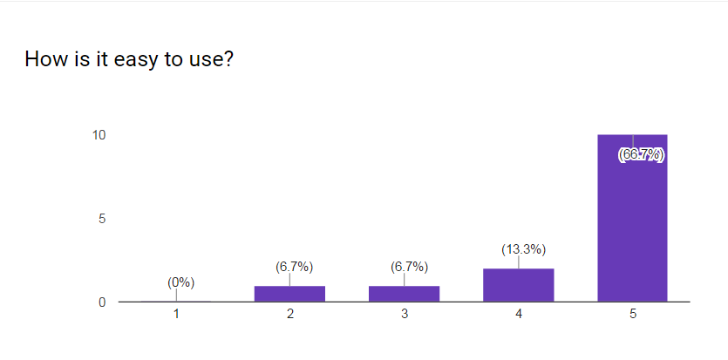

Figure (4‑3): Easy to user search result

In the figure (4-3) show that 66.7% see that the tool is easy to use.

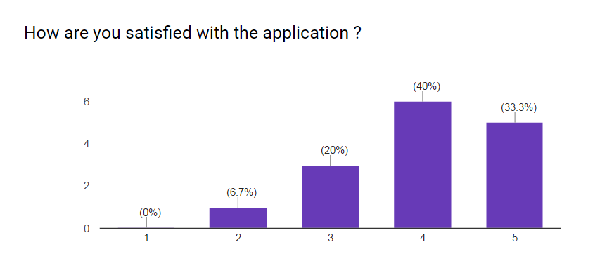

Figure (‎1‑3): Satisfaction research result

In the figure (4-4) show that 33.3% are satisfied with the tool.

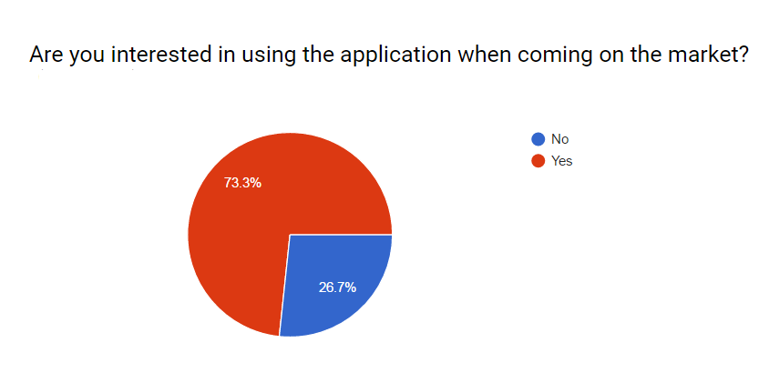

Figure (‎1‑4): Interesting to use research result

In the figure (4-5) show that 73.3% are interested to use the tool.

## Checking to it acceptance:

To make sure of tool acceptance, we must make a questionnaire and publish it to the User also to make sure that have real market.

The following is the questions and the results:

1-Do you find it difficult to find offers?

2- Do you suffer to finding places for offers?

3-Are you existed in the social media or do you have a smartphone application?

4- Do you think that the customer prefers to update the Application?

## Checking and ensure the document:

The last step in the process of verifying the system check the document and audited to make sure that all the program parts are existing and have been documented also make sure that it fits with the form that the department gives to us.

# Chapter Five: Implementation Activities &Outcomes

**Implementation**



## Introduction

Finally, after a period of development and programming system was built a critical stage of Software development process is system implementation, where you create an executable version of software Implementation may involve developing programs in high-or low-level Programming languages or tailoring and adapting generic, off the-shelf System to meet the specific requirements of an Organization.

The implementation stage of software development is the process converting a system specification into an executable system.

It always Involves processes of soft-ware design and programming but, if a prototype methodology to development is used, may also involve refinement of the software specification.

## Installation requirements

The User

**Mobile:**

Android Device

OS 6.0 or later

ARMv7 (Cortex) CPU with NEON support or Atom CPU; OpenGL ES 2.0 or later

## Development Constraint

Since the Tool runs on Android, familiarity with Android needed to develop the Tool.

An IDE needed to develop the application the recommend IDE’s are (Eclipse or Android studio). 5.4 Install Tools

### How to install Tools

for install tool, is download the application from the ‘play store’ and install to device sure must we have an android device.

# 

# Conclusion &Future work



## Introduction

Introductions and conclusions can be the most difficult parts of papers to write. While the body is often easier to write, it needs a frame around it.

An Introduction and conclusion frame your thoughts and bridge your ideas for the Reader.

This chapter is viewing the conclusion of our tool and what is our future work, and how we will develop and improve our tool and what features we will put in our tool.

## Conclusion

This project is for Offers collector.

Where it helps the user to see the Offer and help them to select the product that deal with them and search for specific item.

## Future work

Of future work planned for the development team will be working with the tool to ensure ease of use is smooth and pleased and to work on another platform of operating systems “IOS……Websites “to include the largest group of Offers company and users.